RESOLUTION NO.__________

RE: CERTIFICATE OF APPROPRIATENESS UNDER THE
PROVISIONS OF THE ACT OF THE PENNSYLVANIA
LEGISLATURE 1961, JUNE 13, P.L. 282 (53
SECTION 8004) AND BETHLEHEM ORDINANCE NO.
3952 AS AMENDED.

WHEREAS, it is proposed to renovate the facade at 331-333 Brodhead Ave.

NOW, THEREFORE, BE IT RESOLVED by the Council of the City of Bethlehem that a Certificate of Appropriateness is hereby granted for the work.

Sponsored by: (s)

(s)

ADOPTED BY COUNCIL THIS DAY OF

(s)
President of Council

ATTEST:

(s)
City Clerk

HISTORIC CONSERVATION COMMISSION

CASE # 498 – It is proposed to renovate the facade at 331-333 Brodhead Ave.
OWNER/APPLICANT: St. Bernard’s RC Beneficial Soc / Robert Tierney

The Commission upon motion by Mr. Evans seconded by Mr. Loush adopted the proposal that City Council issue a Certificate of Appropriateness for the proposed work described herein:
- The proposal renovate the facade at 331-333 Brodhead Ave was presented by Robert Tierney, Karen Tierney and Andrew Thear.
- The existing vertical aluminum siding was removed by a previous approval by the Historic Commission and City Council.
- The existing brickote found under the aluminum siding will be cleaned and repaired in-kind.
- A band course will be installed at the location of the former stone band course. The band course will be approximately 4 ½” – 5” in vertical dimension and project form the wall about 1”-1 ½”. The band course will be made of a PVC, “no-rot” type material such as Azek. The window sills will be integrated with the new band course and have a thin covering of the same PVC material.
- Plywood covering the third floor windows will be removed to assess their condition. If possible the existing historic windows will be retained, repaired, and repainted. Vents located in the third floor windows may stay in place. The treatment of those windows should be reviewed with the Historic Consultant.
- The aluminum awning above side door (Brodhead Ave) will be removed.
- The existing signage will be reinstalled at the front (corner) entrance.
- Any substantial changes to the renovation plan must come back to Historic Commission for review.
- The proposed motion was unanimously approved.

CU: cu

By: 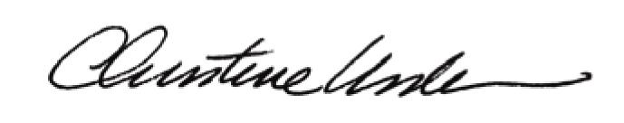

Date of Meeting: May 19, 2014 Title: Historic Officer

